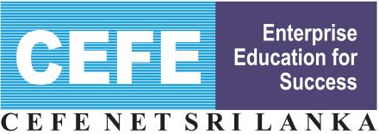

Sampath Saviya 2013-2017
Sampath Saviya is one of the CSR Projects of Sampath Bank started in 2013. Main focus of the Sampath Saviya is strengthening Small and Medium Enterprises through providing training on ‘Entrepreneurship and Business Planning, and credit facilities to those wish to improve their businesses. CEFE Net Sri Lanka had been selected by Sampath Bank as the Training Provider throughout past 5 years.

Performance of Sampath Saviya 2013-2017

Year | No. of Training Programs | Venues of training
2013 | 3 | Embilipitiya, Badulla, Kurunegala
2014 | 16 | Matale, Ratnapura, Kegalle, Kandy, Kurunegala, Matara, Galle, Monaragala, Batticaloa, Kandy, Puttalam, Vavuniya, Kalutara, Orugodawatta(NAITA), Jaffna, Colombo(SLIC),
2015 | 3 | 2 in Kandy and one in Colombo (WCCI)
2016 | 11 | Colombo (Social Service Dept.), Damana, Opanayake, Kegalle(Mushroom Value Chain) Kirinda-Puhulwella, Hatharaliyadda, Ampara, Mahaoya, Colombo(NAITA), Colombo(WCCI), Neluwa
2017 | 11 | Kahatagasditgiliya, Colombo, Kandy, Rajagiriya, Jaffna, Karuwalagaswewa, Giriulla, University of Ja-pura, Moratuwa, Gampola

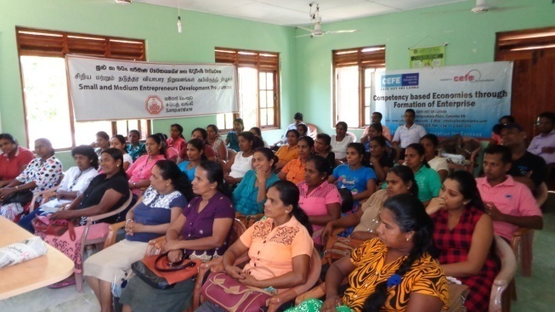
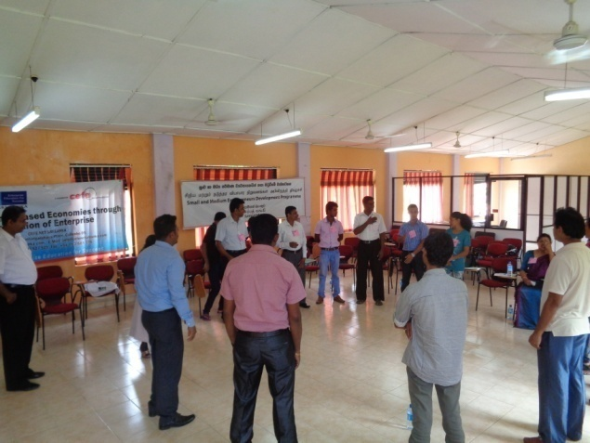
According to the program records, over 1,000 Small and Medium Entrepreneurs have been trained.
Sampath Saviya Training package have been diversified into value chain based training with collective participation of main buyer, small producers, bank and support service organizations. The value chain based Sampath Saviya Training is conducted according to following model,
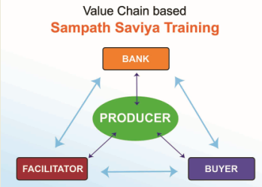
- Buyer purchases products from small producers
- Bank provides credit facilities to small producers
- Bank provides mass scale credit facilities to Buyer
- Bank is having accounts of buyer and all producers. Transactions are done through bank accounts
- Buyer transfers technology to producers
- Facilitator provides extension services and co-ordinates the entire project
(Facilitator could be Government, NGO or CSR unit of Buyer)
This is one of the creative training packages developed by CEFE Net Sri Lanka for Sampath Saviya. This model has been tested with Mushroom and Dairy sectors in Kegalle and Ampara Respectively.
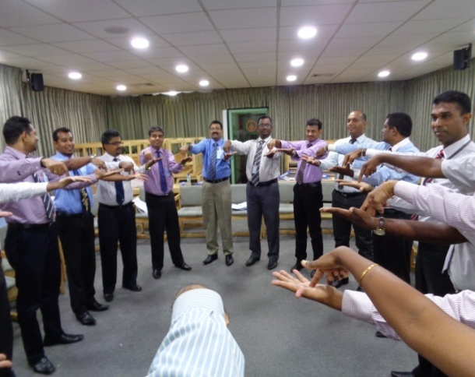
Apart from entrepreneur training, CEFE Net Sri Lanka has trained Branch Managers of Sampath Bank. Main intention of this program was to appreciate the need of ‘Credit Plus’ approach in a competitive banking environment. A branch business plan was introduced during the program and branch managers were assigned to complete the business plan within a month after the program. CEFE Net Sri Lanka has no records on how many branch managers have submitted the branch business plans.
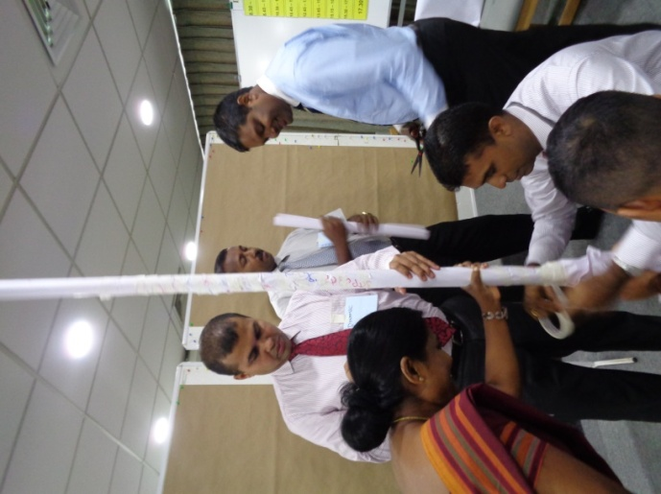

Sampath Saviya Trade Fair 2017
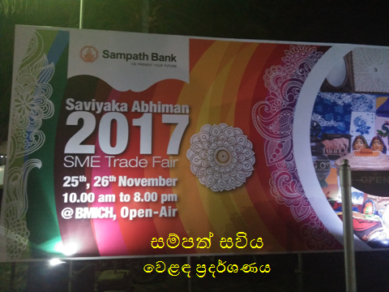
Sampath Bank has organized a national level SME Trade Fair ‘Saviyaka Abhiman’ on 25-26 November 2017 at BMICH to facilitate SMEs who have participated in Sampath Saviya Program during 2013-2017. 76 stalls have been provided free of charge to Sampath Saviya SMEs to exhibit and sell their products.
CEFE Net Sri Lanka, Export Development Board, Ceylon Chamber of Commerce and University of Sri Jayawardhanapura have participated with information stalls to facilitate this trade fair.
